1. Yes, the three RNASeq replicates compare to each other based on PCA and show great variance. Yes, there is a variance of (31.53% + 23.36 % = 54.89). Yes, it is a good variance; however, the data looks good.
2. Yes, the seedling root and the root tissues are positioned near each other in the PCA plot, which is expected as they share similar biology and anatomical features.

Similarly, leaf and leaf drought are also positioned near each other because the leaf drought feature is related to the leaf and is closely positioned in the PCA plot.

The seedling shoot and internode also share close anatomical features in the plant and are positioned close in the PCA plot.

In the same way, the M1 seed and M2 seed are also in the top position in the PCA plot. They both are the seed tissue types and would have similar structure and homology compared to other tissue types in the plot and share close linkage in the plot.

1. Studying the root and leaf samples would be the most biologically interesting comparison. As these tissues have a huge difference in their tissue structure: root (underground) and leaf (aboveground), and are responsible for different functions.

Based on the x-axis of the PCA plot, the leaf and root tissues are the farthest one positioned in the PCA plot, which suggests a broad difference in their gene expression and are biologically the most variant. So, a further study on these would be biologically interesting.

The Gene Ontology enrichment of the Arabidopsis_1 gave the following output:

1. The most significantly enriched GO terms for set 1 of Arabidopsis are for the ones with the lowest Bonferroni p-values.
2. So, here it is:

* Response to abiotic stimulus
* Response to chemicals
* Response to oxygen-containing compound
* Response to water, etc.

It looks like it’s the leaf vs leaf drought tissue experiment.

1. The gene ontology of the Arabidopsis 2 gave the following output:

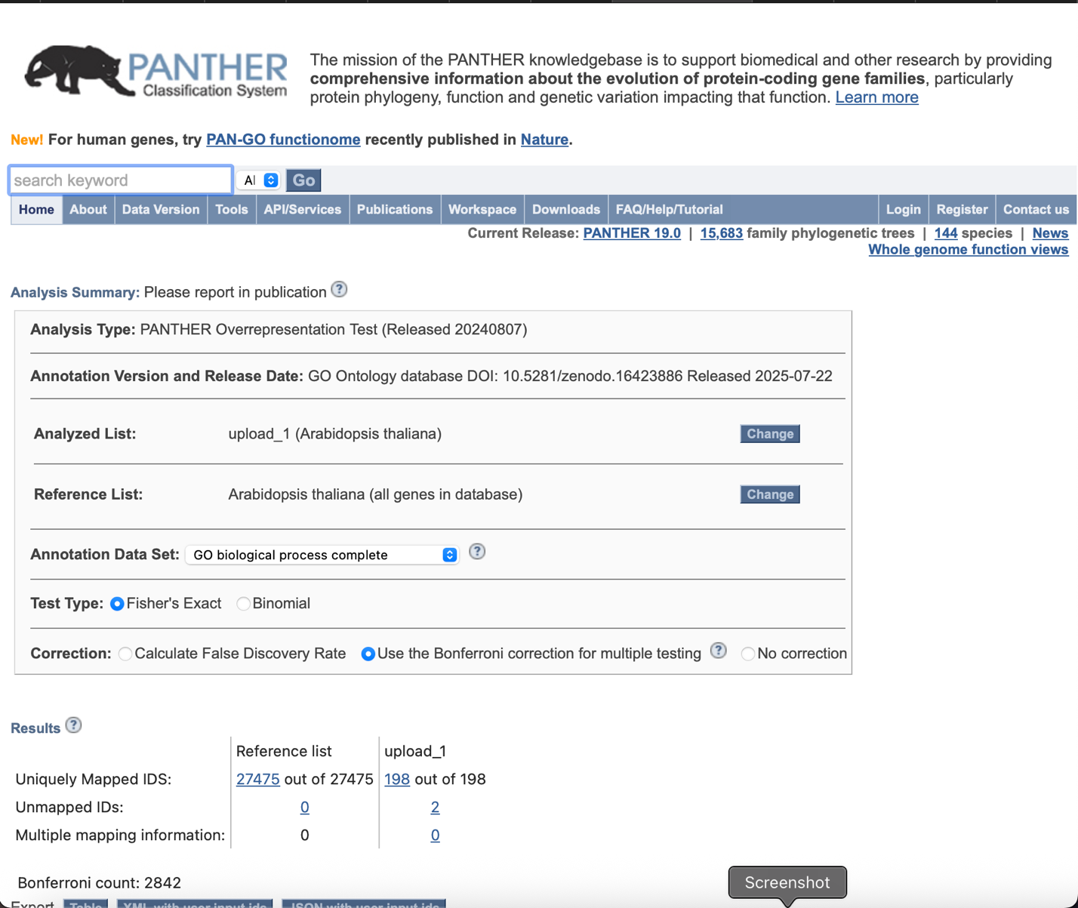

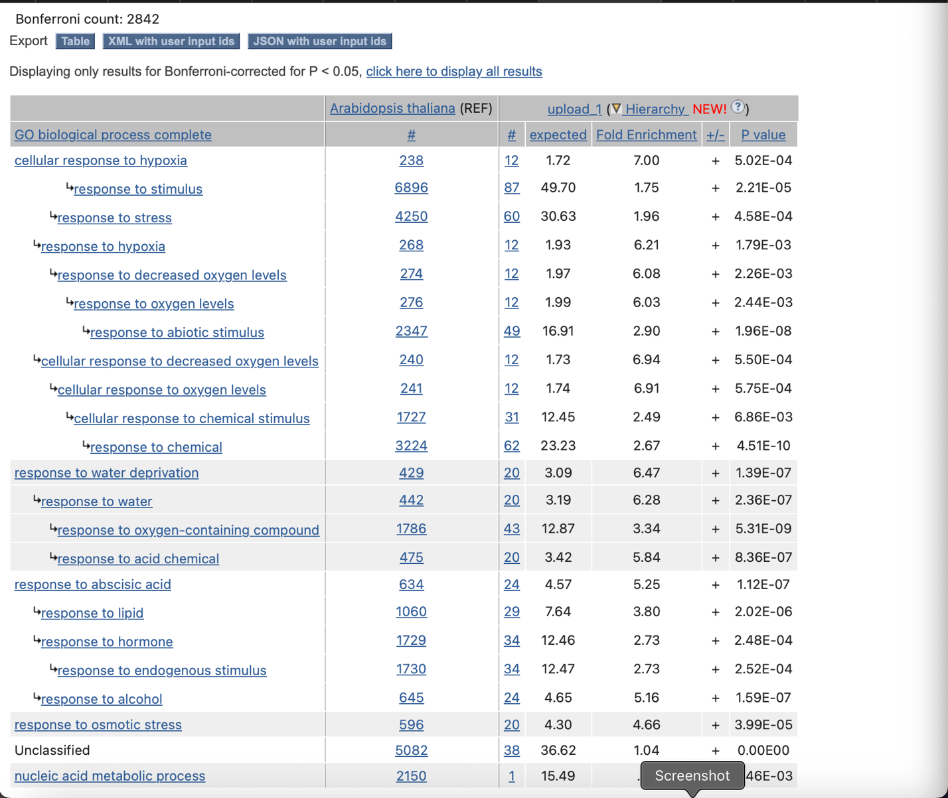

Here, the most significantly enriched GO terms for set 2 are:

* Response to water deprivation
* Response to water
* Response to oxygen-containing compound
* Response to acid chemicals
* Response to osmotic stress
* Nucleic acid metabolic process